Sprint 3 - Manual Testing Document:

**Testing Set One:** Tapping ‘Forgot Password’ link and entering a valid email (that is, one with an account already)

Testing Procedure:

* Tap on ‘Forgot Password’ link on login screen
* Enter an email into textbox and tap on ‘Send Reset Email’ button
* On the new confirmation screen, click on ‘Login’ link
* Go to your email and click on provided link
* Enter in new password
* On the app, login with the new password

Test Results and Follow Up:

1. Tapping on ‘Forgot Password’ link: Successful. App navigated to ‘Reset Password’ Screen

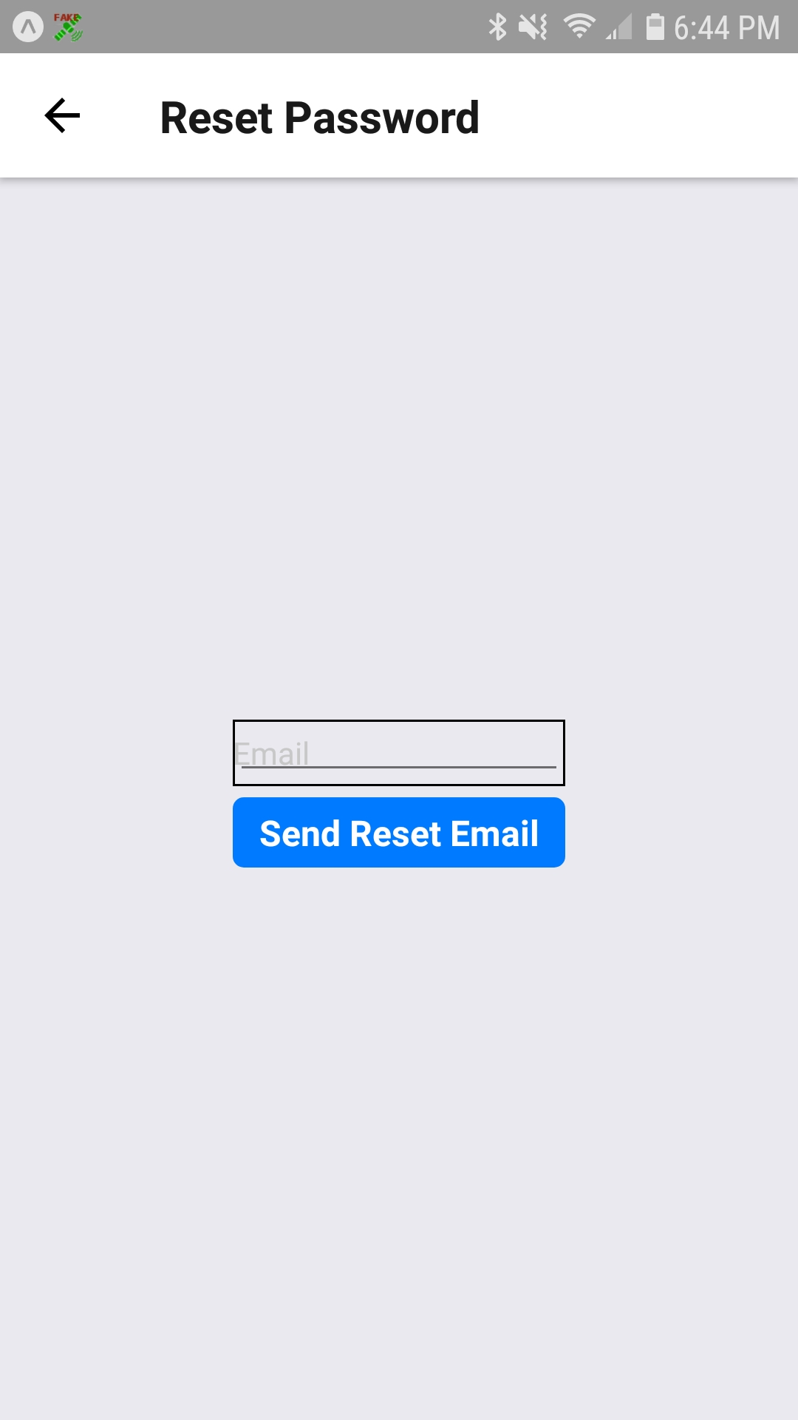

1. Entering an email: Successful. The email already has a profile on the server and therefore returned success:true. The app navigated to confirmation screen.

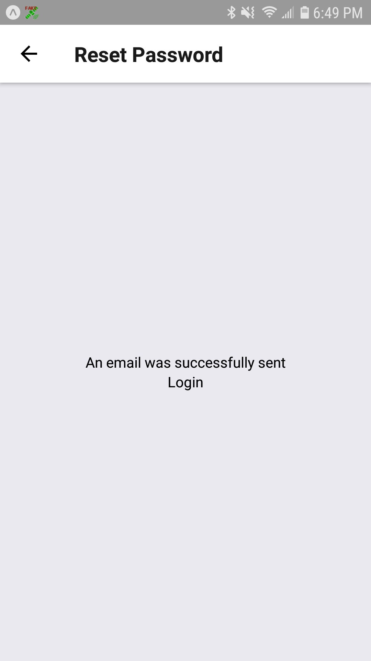

1. Clicking on ‘Login’ link: Successful. App navigated to ‘Login’ Screen

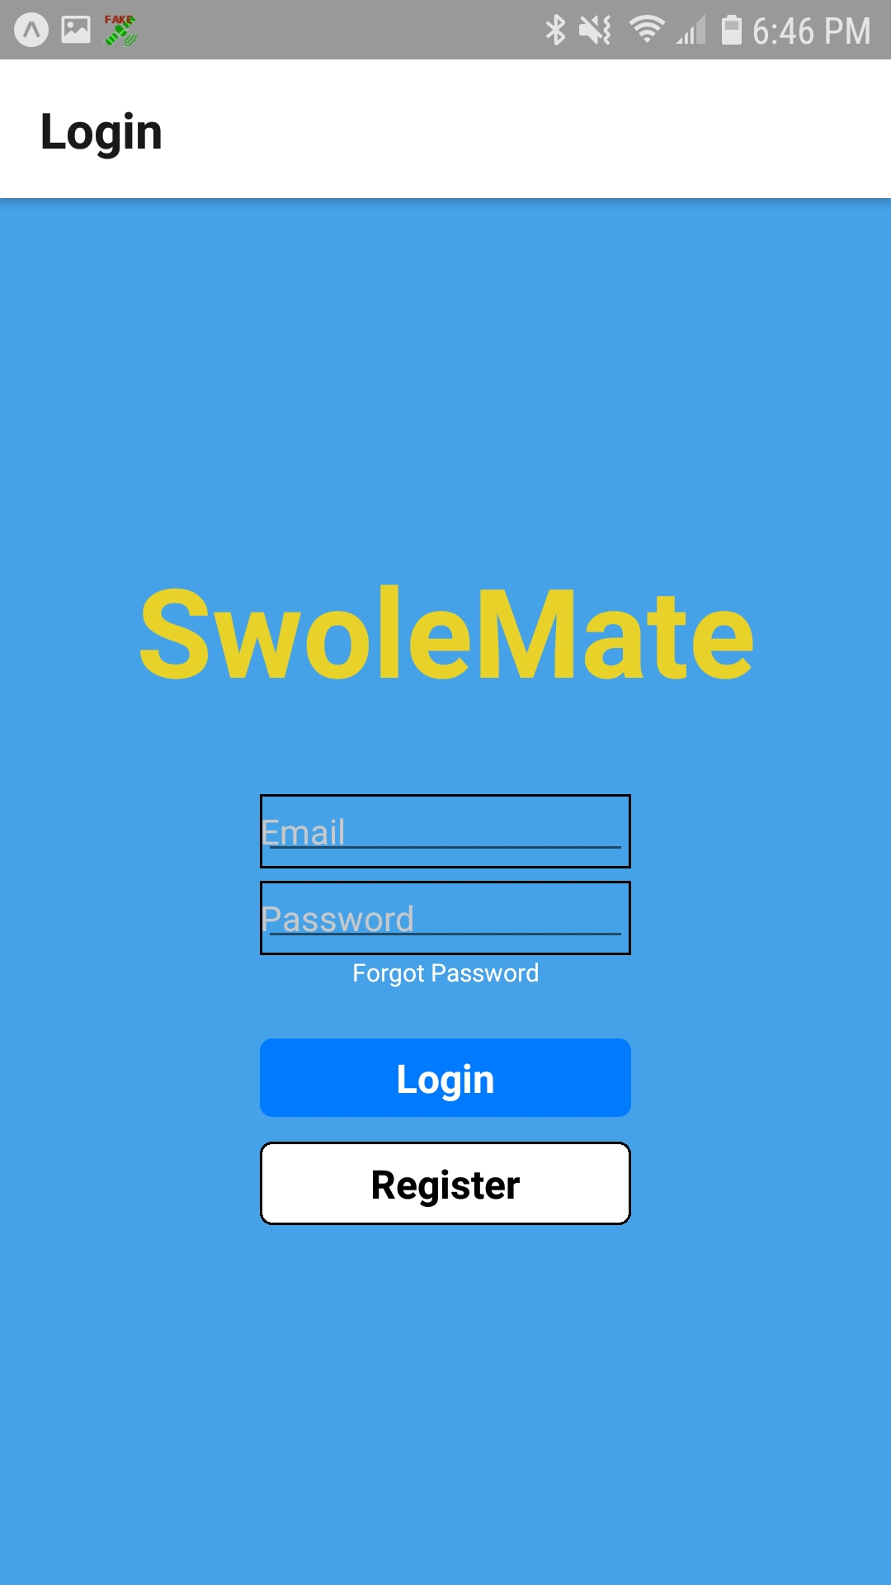

1. Clicking on link in email: Successful. Browser opened reset password page

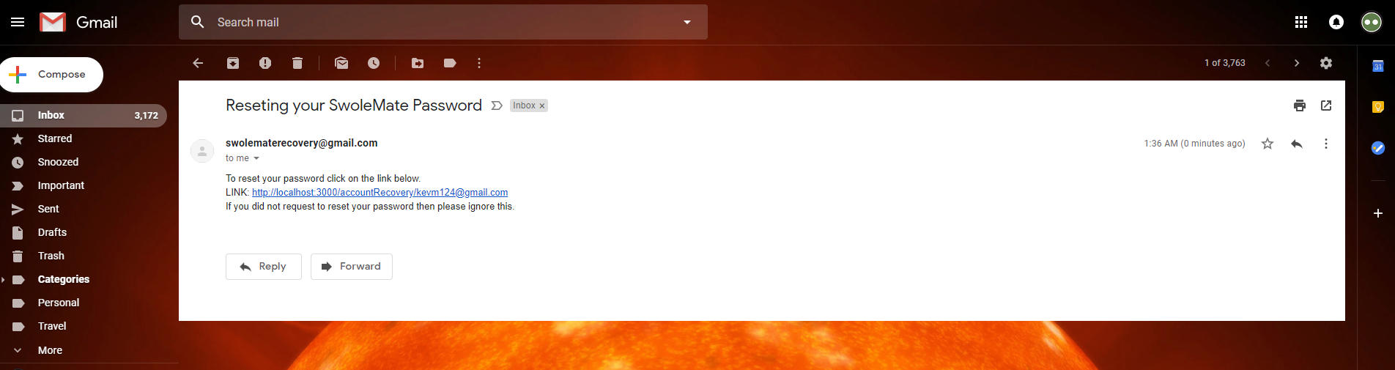

1. Entering in new password: Successful.

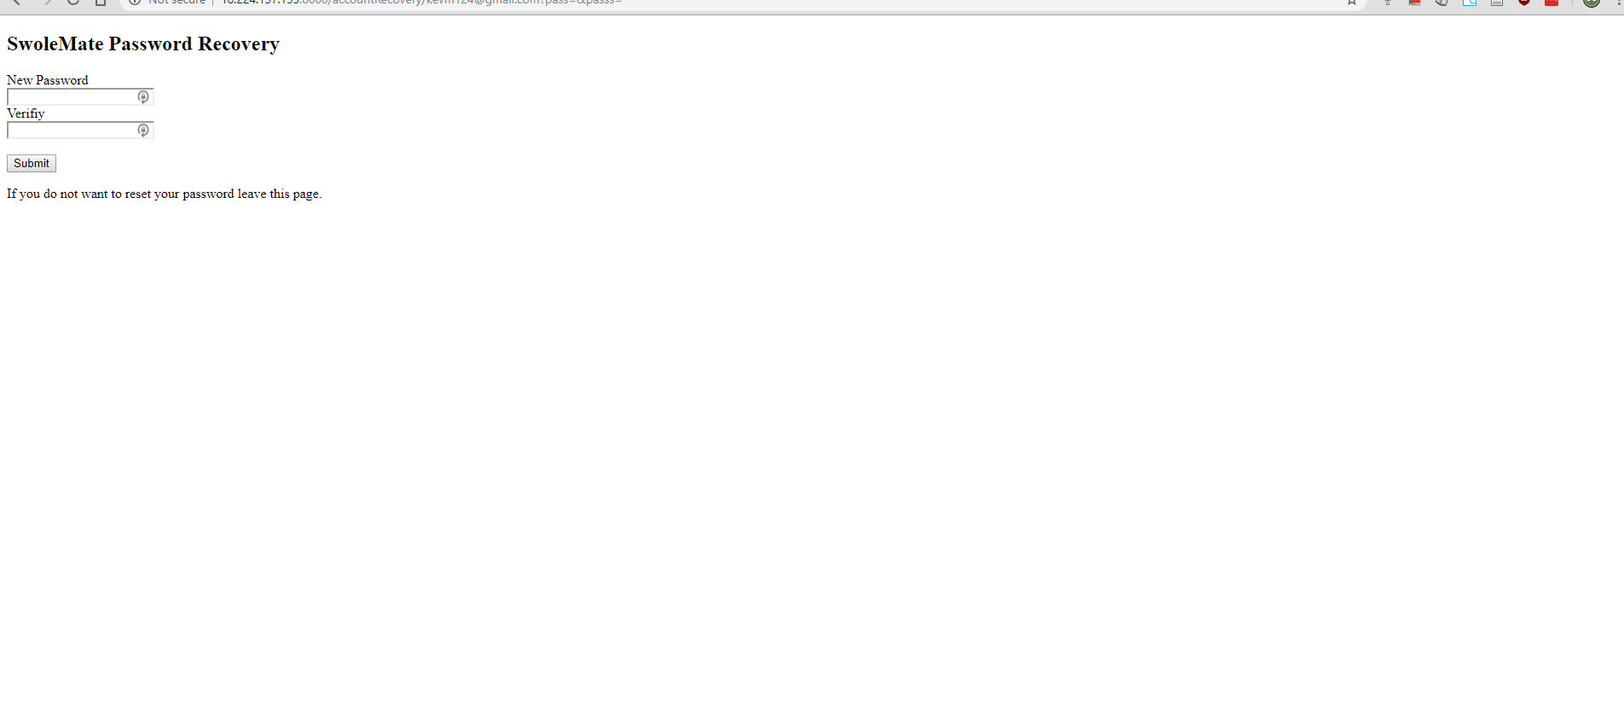

1. Logging in with new password: Successful.

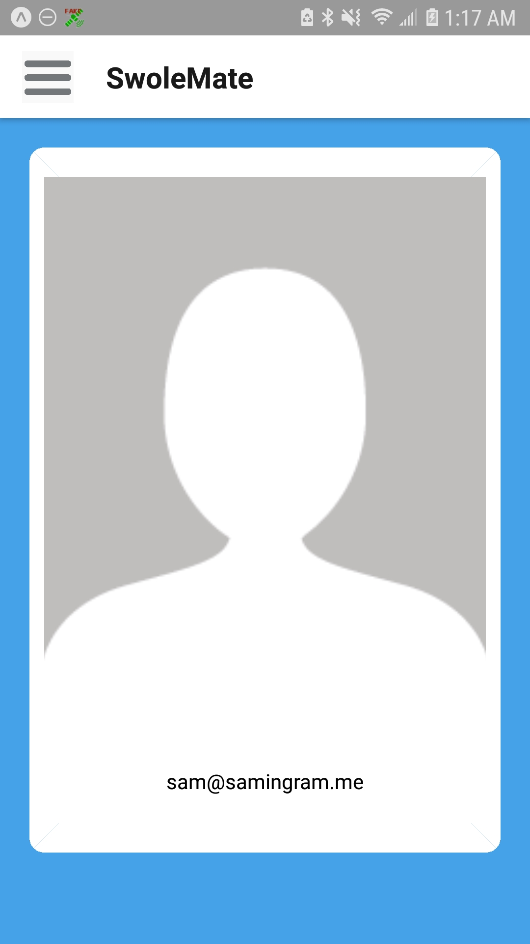

**Testing Set Two:** Creating and Logging into account from either Google or Facebook.

Testing Procedure:

* If an account already exists through my Facebook/Google, delete it from the Mongo CLI
* Go onto the app and click the Register button on the Login screen
* Click on either “Register with Facebook” or “Register with Google”
* Click through the prompt if there is one and wait for the account to be created
* After the account is made, Log out and try logging in with the respective login button
* Verify that the login is performed successfully

Test Results and Follow Up:

1. If your account does not exist in SwoleMate, you should be able to login with Google or Facebook.
2. If successful you will see a screen with “Register with Facebook” and “Register with Google”
3. If successful you will be prompted with a google/facebook login. (not shown in pictures)
4. If you successfully created an account you will see a tutorial screen screen showing you how the app works.
5. If you have done everything right you should be able to log out and log back in with what you used.

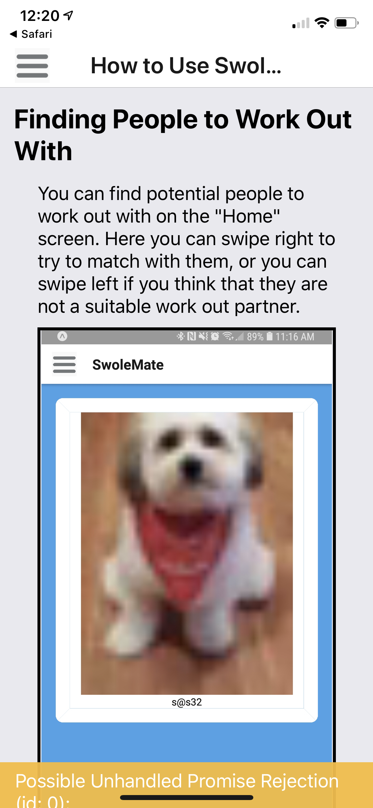

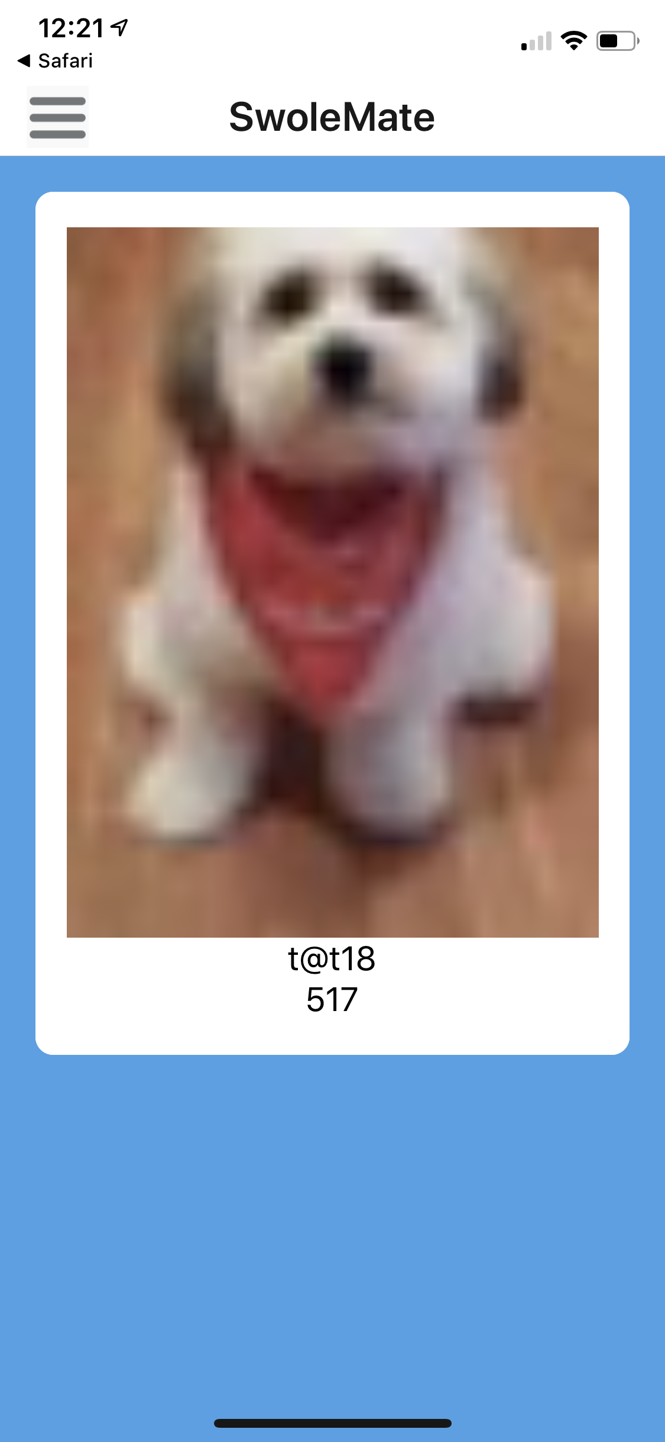

**Testing Set Three:** Tutorial Screen after Register and can get to it afterwards

Testing Procedure:

* Tap on ‘Register’ button on login screen
* Populate each field with the expected data
* Tap on ‘Register Account’ button
* Tutorial should appear, scroll to the bottom
* Tap on the menu icon (three horizontal lines) in the upper right corner
* Tap on ‘Home’ in the pop out menu
* Tap on menu icon again and Tap on ‘Tutorial’ in the pop out menu

Test Results and Follow Up:

1. Tapping on ‘Register button: Successful. App navigated to Register Screen
2. Populating the fields and clicking register button: successful. App created user and navigated to Tutorial.
3. Tapping on menu icon and tapping ‘Home’: Successful. App navigate to ‘Home’ Screen.
4. Tapping on menu icon again and tapping on ‘Tutorial’: Successful. App navigated back to the Tutorial Screen.

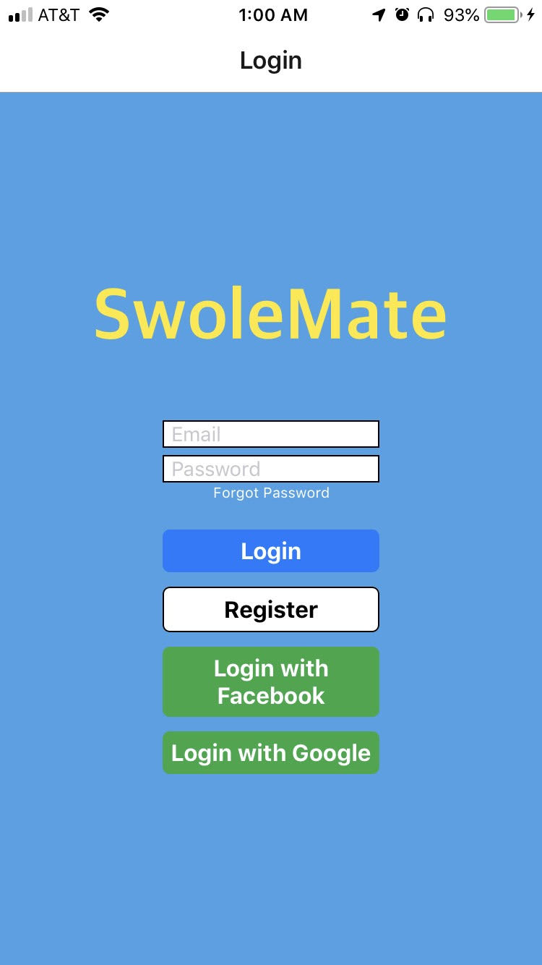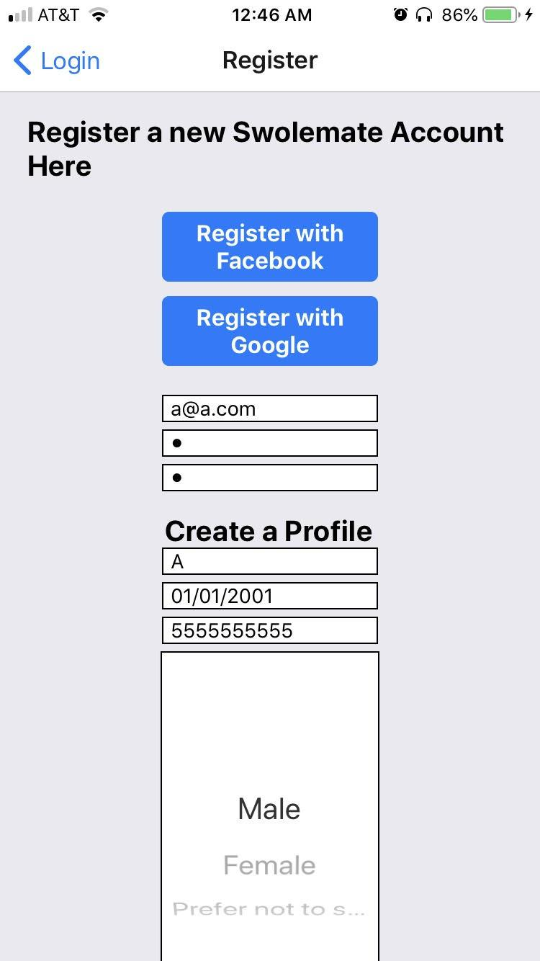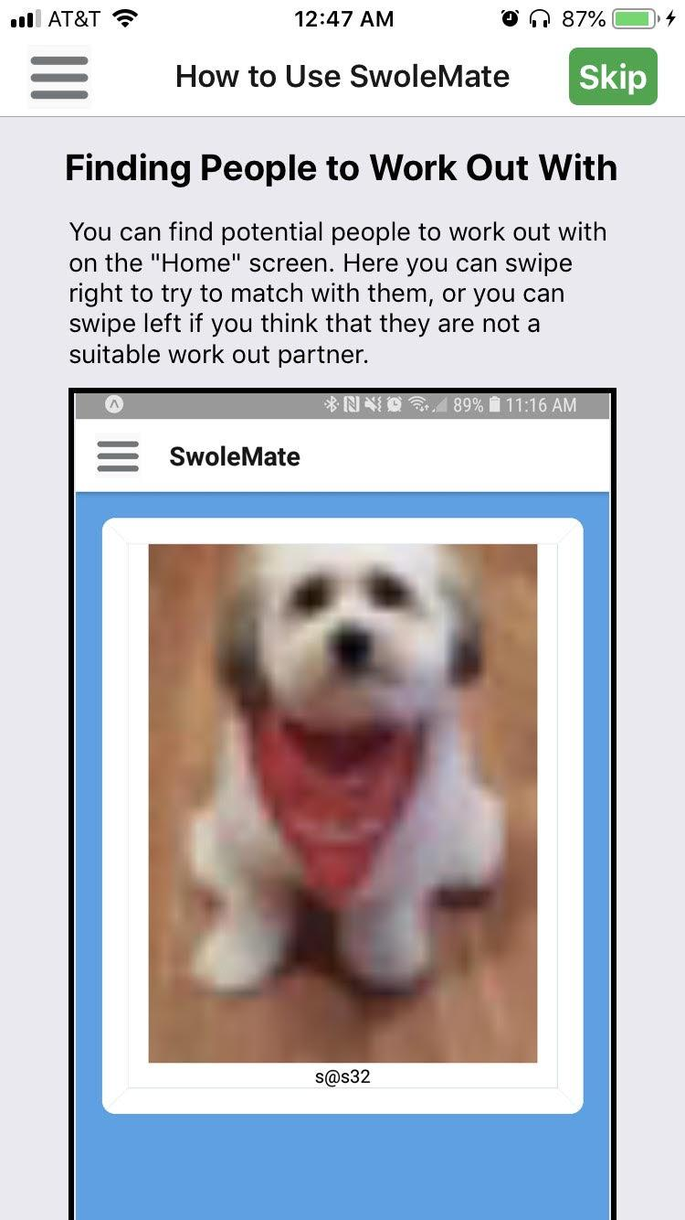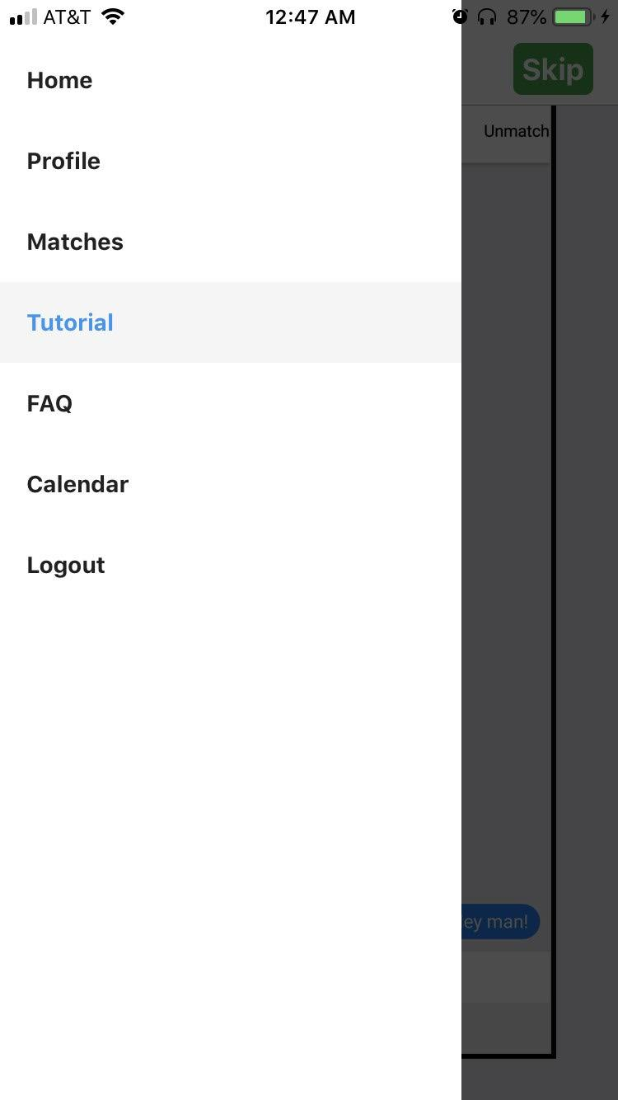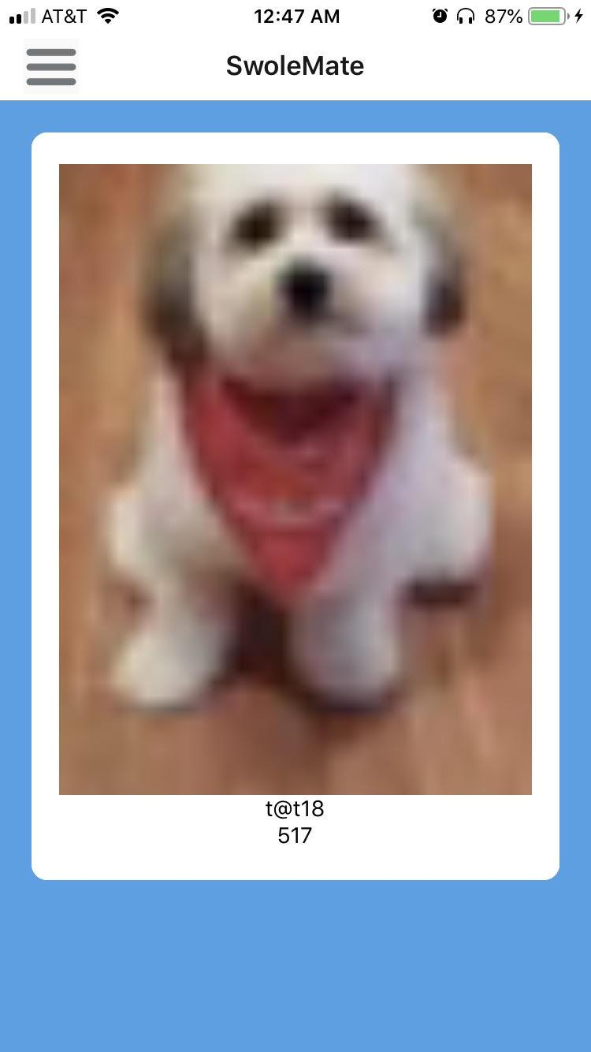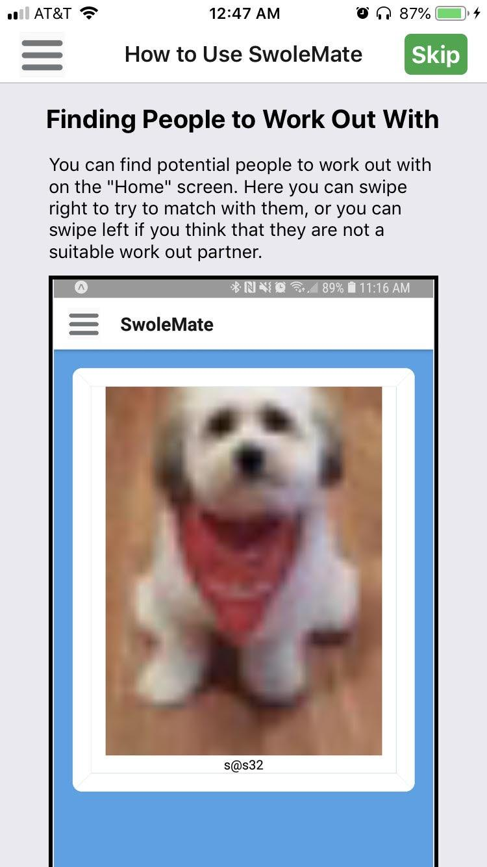

**Testing Set Four:** Switch for Basic Info

Testing Procedure:

* Tap on the side bar in the top left of the screen
* Tap on the ‘Profile’ option
* Tap on the ‘Edit’ button in the top right of the screen
* Scroll down until you see ‘Only show basic info’ and flip the switch
* Finally click save!

Test Results and Follow Up:

1. If the side bar is clicked you should be prompted with a side bar where you will have different options to click on.
2. If you click profile you should open up the profile screen where you can see your profile picture and other things.
3. If you clicked on ‘edit’ you should see a lot of options to change different things on your account.
4. If you flipped the basic info switch it should turn green on the right side of the switch.
5. Then click save, and if save successful other people won't be able to see certain info about you.



**Testing Set Five:** Report user

Testing Procedure:

* Tap on the user that you wish to report to view their profile
* Scroll through the profile of the person
* Click on the report button at the bottom
* Type in your message for reporting
* Then click ‘send report’

Test Results and Follow Up:

1. If you tapped on the user you will be shown the users profile
2. If your scrolled down to the bottom you should see a ‘report’ button.
3. Once you click on the report button you will be prompted with a report message asking if you are sure
4. Once you click that you will see a text box where you can type your report message
5. Finally click submit and you have sent the report message and should go back to the profile page.

 

**Testing Set Six:** Edit favorite workout location

Testing Procedure:

* Tap on the side bar in the top left of the screen
* Tap on the ‘Profile’ option
* Tap on the ‘Edit’ button in the top right of the screen
* Scroll down until you see ‘Add a Workout Location’ and tap
* Enter the location you wish to workout at
* Then click scroll down and click save!

Test Results and Follow Up:

1. If the side bar is clicked you should be prompted with a side bar where you will have different options to click on.
2. If you click profile you should open up the profile screen where you can see your profile picture and other things.
3. If you clicked on ‘edit’ you should see a lot of options to change different things on your account.
4. If you selected ‘Add a Workout Location’ you will be prompted with a line you can type on. Once you start typing you it will auto complete. If you see the one you are trying to type click on it.
5. Then click save. If everything is successful you should be able to see your fav workout location in your profile.



**Testing Set Seven:** Events are displayed and can be added to Calendar

Testing Procedure:

* Tap on the menu icon (three horizontal lines) in the upper right corner
* Select ‘Calendar’ from pop up menu
* Observe events populate the calendar
* Tap on the plus icon in the bottom right corner
* Fill out new event form and tap ‘Create Event’ button
* Observe new event is present in calendar

Test Results and Follow Up:

1. If the side bar is clicked you should be prompted with a side bar where you will have different options to click on.
2. If you click calendar you should be show a list of days with your events.
3. You can then click on the + sign in the bottom right to create an event.
4. Go through all the prompts until you can click create.
5. If successful you will see your event added to your calendar on the correct day

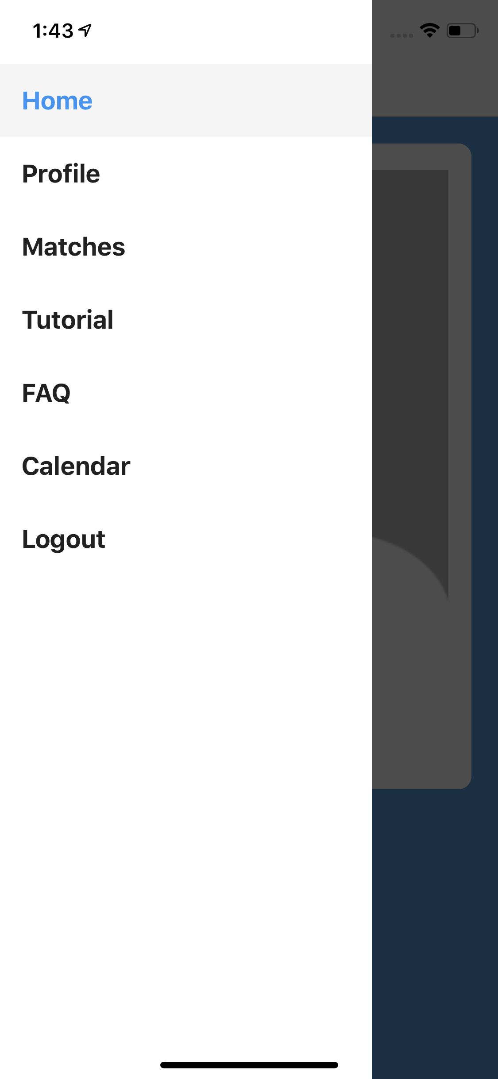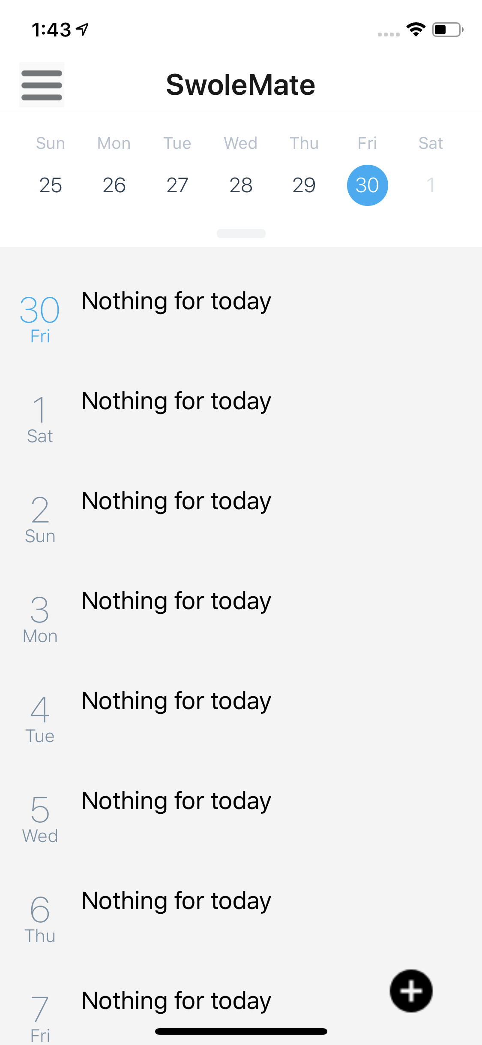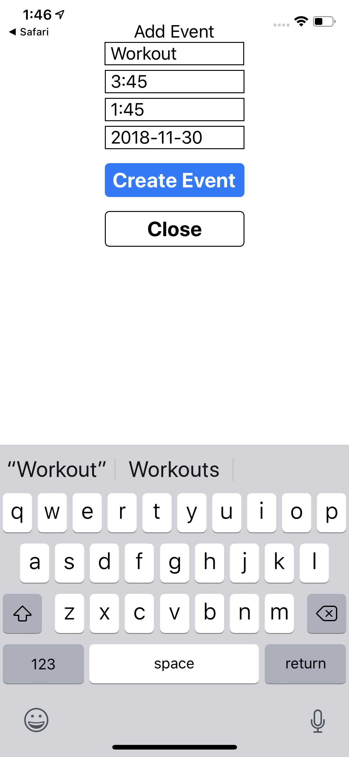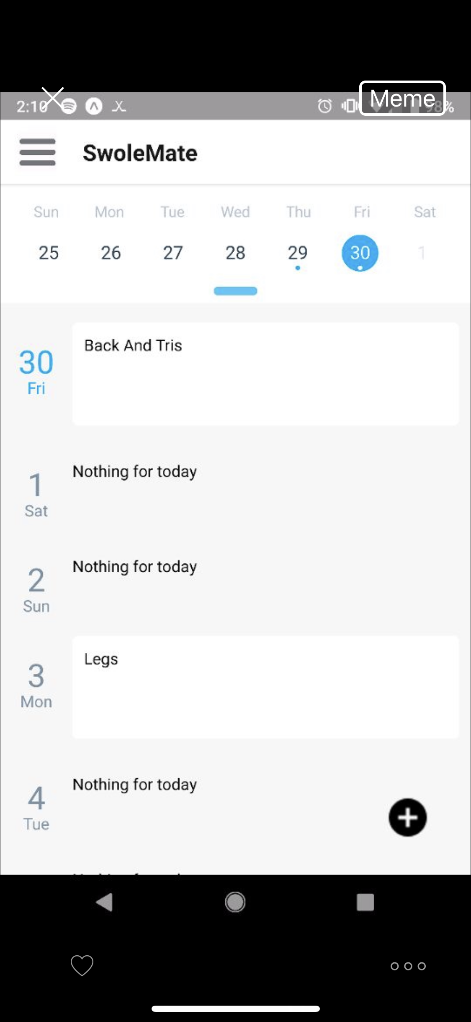

**Testing Set Eight:** Share profile

Testing Procedure:

* Tap on profile of user you wish to share
* Tap on ‘Share this Profile’ button
* Select one of your matches to share the profile with

Test Results and Follow Up:

1. Tapping on profile brings up the expanded profile view of that user
2. Tapping on ‘Share this Profile’ button brings up a view of you matches
3. Selecting a match brings up a confirmation messages that the profile was shared
4. Bringing up the conversation screen with the user you shared a profile with should display a message with a link to the shared profile
5. Tapping on link in message should bring up expanded profile view of the shared user

